|  |  |
| --- | --- |
| Service, Quality and Environment Europe Product Behaviour | **Operation Manual** |

**STRICTLY CONFIDENTIAL**

**Operation Manual for:**



**Applicable as of 25 April 2019**

**Drafted by: Bart Koopmans**

**Issue date**: 25 April 2019  
**Revision:** 1.2  
**Applicable for:** All SONY Electronics Products

**Table of contents**

1 Revision history 3

2 Introduction 4

2.1 Objective 4

3 What is SONAR, rules of use and judgment criteria 5

3.1 Purpose of the tool 5

3.2 Report trigger parameters 5

3.3 Difference between a potential and a required report. 6

3.4 Report judging criteria 7

3.5 Localisation of SONAR 7

4 How to use SONAR 8

4.1 Sonar report overview – language selection 8

4.2 SONAR report overview – functionalities 9

4.3 Report screen 10

4.4 Submitting a report 11

5 Who to contact in case of issues? 15

# Revision history

|  |  |  |  |
| --- | --- | --- | --- |
| Date | Revision | Changes | Revised by |
| 25/03/2019 | 1 | Original publication | Bart Koopmans |
| 26/03/2019 | 1.1 | Various updates on the document | Bart Koopmans |
| 25/04/2019 | 1.2 | New question type (comment) added | Bart Koopmans |
|  |  |  |  |
|  |  |  |  |
|  |  |  |  |
|  |  |  |  |

# Introduction

## Objective

Purpose of this manual is to give clear instructions on how to use the SONAR reporting tool.  
In this manual we explain the purpose of the tool, what we expect and how to submit a SONAR report.

Implementation of the SONAR tool may vary for each service partner, however the notification and fill-in screens will be the same for all.   
  
This manual will be further updated when new features and functionalities are added.

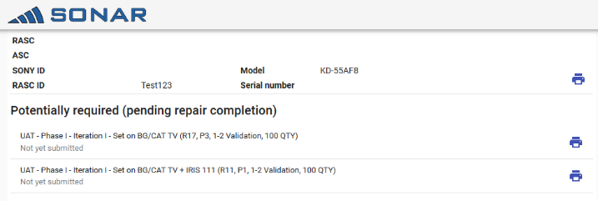

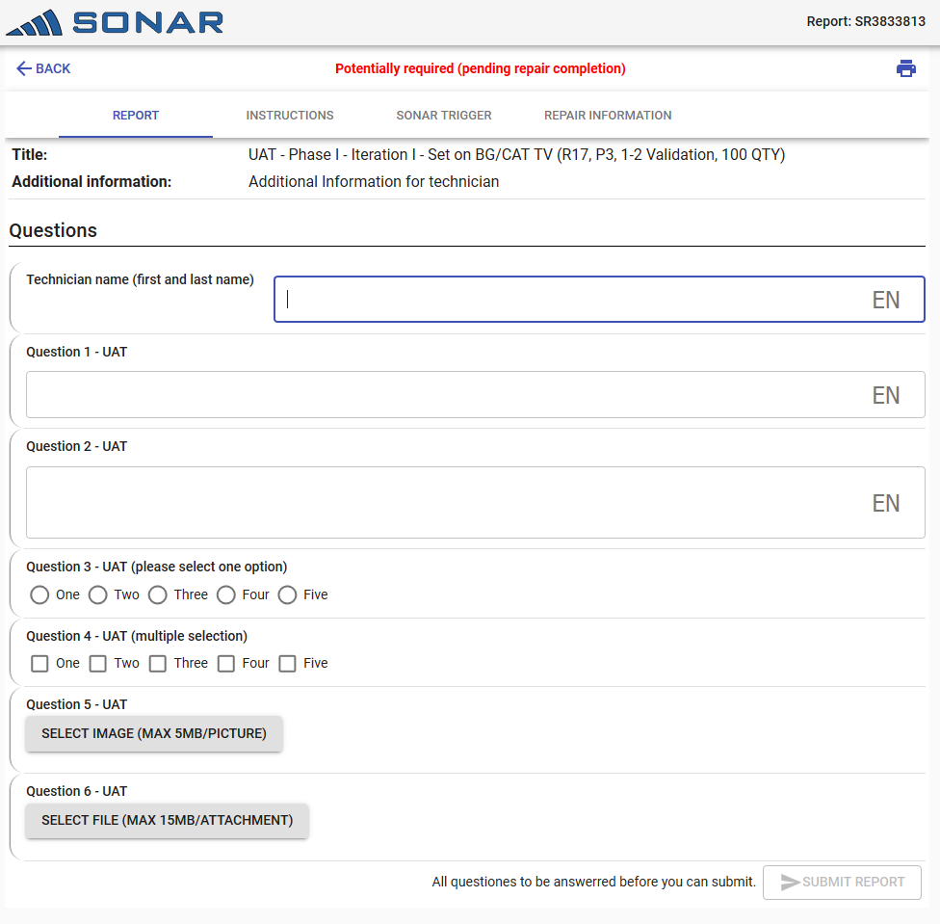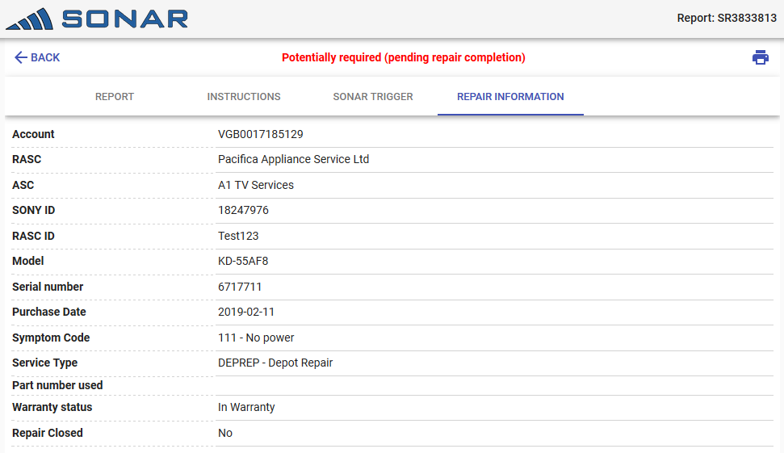

# What is SONAR, rules of use and judgement criteria

## Purpose of the tool

* As the quality of our products is one of the key objectives of SONY we want to properly understand why products are being repaired. In order to do this, we analyze our repair data in detail. In certain cases however we may require more detail than what we are receiving today.
* Based on this repair analysis more detailed questions / pictures / system logs etc may need to be asked from the technician at the time of the repair.
* To achieve this SONAR is integrated in our communication system between the (R)ASC and SONY. This allows SONAR to trigger report requests at the start of each repair based on a set of configuration parameters.

## Report trigger parameters

Based on one or a combination of below parameters a report request will be triggered:

* + Model
  + Serial number(s)
  + IRIS Symptom code
  + Incoming SW version(s)
  + Part(s) consumed
  + Service type
  + Country/(R)ASC/Sub-ASC

Important to note:

* Sony will strive to keep the number of report requests to a minimum.
* The reports that may be applicable will be offered at the beginning of the repair. This will allow the technician to know beforehand what additional information may be required during the repair.
* The technician can also print these reports in case for example an in-home repair is registered and he/she will not have an active internet connection during the repair.
* The report URL is also compatible with mobile devices. This will allow the technician to use a mobile phone / tablet while on the road to submit the request.

## Difference between a potential and a required report.

As not all information may be available at the beginning of the repair (e.g. parts consumed, diagnosed IRIS symptom code, etc) reports will have different statuses linked to them.

Therefore, **only at the end of the repair (repair closure) the report(s) are to be completed and submitted.**

* **Potential report**
  + Based on the repair information already available and the configured trigger parameters a list of SONAR reports which may **potentially need to be completed at the end of the repair** is shown.
  + For this list to be populated we will look at following criteria :
    - Model
    - Customer reported IRIS code
    - Serial number
* **Required report**
  + In case all confirmed repair information matches the reporting criteria, upon repair completion the report will be marked as **required**.
  + **Only Required reports need to be completed in full and submitted to Sony**.

## ****Report judging criteria****

All submitted sonar reports will be reviewed by SONY Engineering members.

These will review the answers, correct the auto-translations, check the attachments uploaded (where required) and review the diagnosed IRIS symptom code.

Based on this review the report will be judged as Useful or Not Useful. Further detail regarding the reason why will also be provided.

The current reasons are:

|  |  |
| --- | --- |
| **Report scoring reasons** | |
| **Useful** | **Not useful** |
| Very detailed information provided | Not all questions properly answered |
| Potential issue detected thanks to this report | Answers not linked to the question |
| All questions properly answered | Answers unclear / lacking detail |
| This report helps our ongoing investigation | No picture attached |
| Good alternative repair suggestion | No video attached |
|  | Requested file(s) not attached |
|  | Incorrect repair action taken |
|  | Pictures not detailed enough |
|  | Movie not detailed enough / audio missing |
|  | Incorrect diagnosed IRIS Symptom code |

## Localisation of SONAR

As in Europe we are supporting many languages we opted for SONAR to support multiple languages.  
In this sense we will offer a translated version of SONAR report requests in the following languages:

|  |  |
| --- | --- |
| English | Dutch |
| French | Italian |
| German | Polish |
| Spanish | Portuguese |
| Greek |  |

For other languages we will not offer a localised question list by default so there the questions will be offered in English.

In case there are questions with open answers you can enter the reply in your own language. How this is working will be explained in the next chapter.

# How to use SONAR

In this section we will explain how SONAR should be used. Depending on the implementation within your service centre there can be some additional screens shown before; please check your local operation manual for support.

The Sonar reporting tool can also be used on mobile devices. Please check with your local helpdesk if you want to make use of this feature.

## ****Sonar report overview – language selection****

If a repair is entered in your local repair management system or in the 3C GUI, a popup can be shown indicating that for this particular repair, SONAR reports may be applicable.  
Once you click on the link, depending on your specific user configuration an initial language selection may be shown.

This will be the case in:

* Belgium: Dutch, French, German
* Switzerland: German, French, Italian

Please select the language of your choice to proceed.

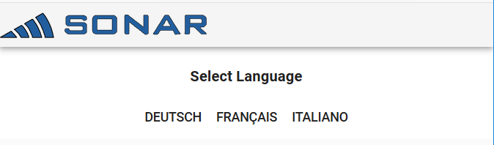

## ****SONAR report overview – functionalities****

In the overview screen you will find all the reports that are potentially applicable for the service event you have just created.

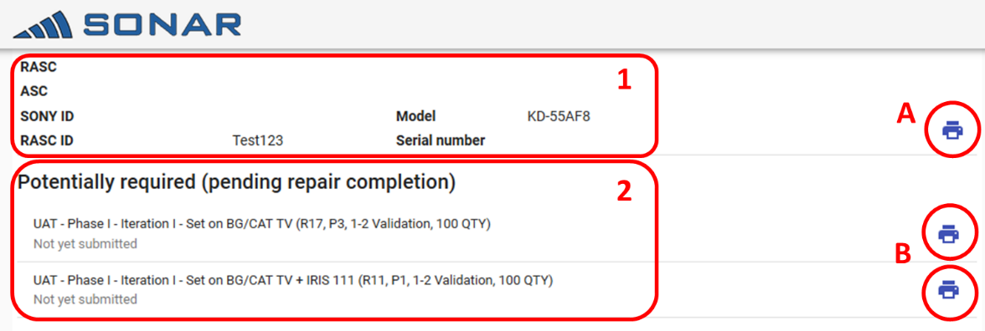

On the top (1) you can find the basic repair details.  
Next to that you can find a print all button (A). This will allow to print / export as PDF all reports linked to that repair.  
Below (2) you can find the list of potential reports linked to that repair.   
You can also opt to print individual reports by clicking on the pint option next to the listed report (B).

Notes:

* Once a report has already been submitted, this print option will disappear.
* In case there is only 1 potential report the system will immediately open that report and this overview screen will not be shown.

## ****Report screen****

After selecting a report the actual report fill-in screen is opened.

In the top menu you can find various options.

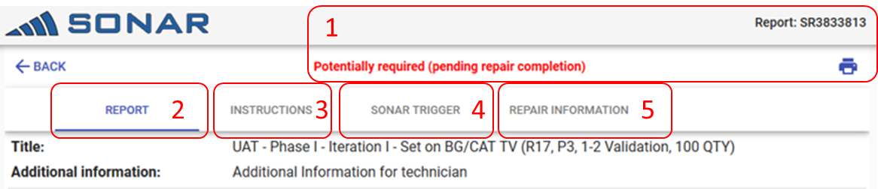

1. Gives an indication whether the report is Required or Potential. It will also show the individual report ID and the print button.
2. **REPORT:** Shows the report that needs to be completed. Here you can fill in all the details and submit the report
3. **INSTRUCTIONS:** a short how-to-use instruction text
4. **SONAR TRIGGER:** Shows why this report is triggered and which conditions the repair needs to meet in order for the report to become required or not.
5. **REPAIR INFORMATION:** gives the basic repair information, this avoids the need for basic repair information duplication.

## Submitting a report

**Technician name (A)**: please enter your/technician first and last name in here. In case there would be questions from SONY regarding a report, this makes it easy to trace the actual technician.

There are 4 different question types:

* **Single line** (1) free text answer

A short answer is expected for this question

* **Multi-line** (2) free text answer

A more detailed answer is expected for this question

* **Single selection** (3) answer
* **Multi-selection** (4) answer
* **Comment** This will provide additional information / instructions linked to this specific report. No answer can be provided. Please read these carefully and follow these instructions in case the report is required.

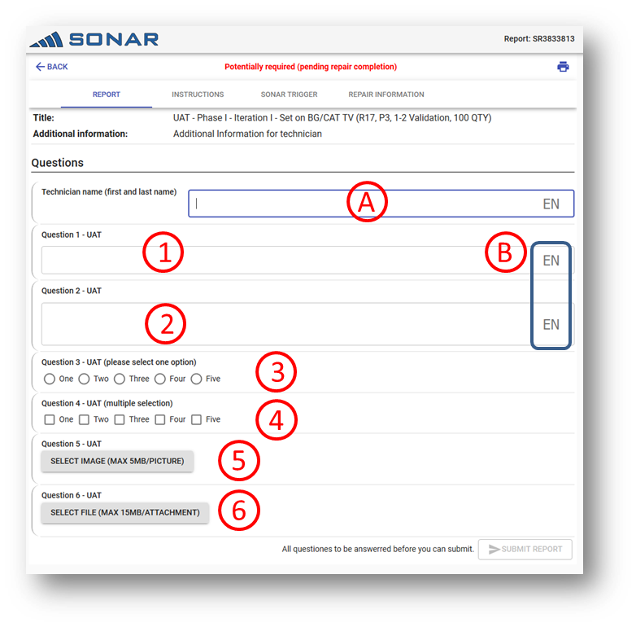

You can answer the question in your own language. Make sure to click on the language selector at the right hand side of the box (B) to set your language.

By default, the language selection is linked to language setup of your account or the initial language selection you made in case more languages can be applicable for your country.

Next to the questions there are 2 further attachment types:

* Image attachments (5). Maximum image size is indicated in the question.

Supported image file formats are: JPG, BMP, RAW,

* File upload (6): Maximum file size is indicated in the question.

Supported file types are: Office document files, AVI, MP3, MP4, ZIP, 7Z, RAR, ARC, PDF, WAV, TXT, CSV, AFPHOTO

## Printing reports

To accommodate the technicians who do not have internet access during in-home repairs or in certain workshop setups, the reports can also be printed. This allows the technician to complete the report offline. This report will then need to be inputted in the digital report upon repair completion.

The printed document shows all details and the report criteria. The technician can fill in the details on the document in the fill-in boxes (indicated with )

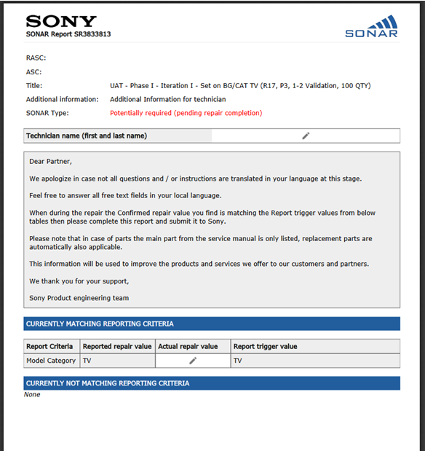

On the front page you can find following information:

* + Basic repair and report title and report details
  + Fillin field for technician name
  + Instructions
  + Reporting Criteria
    - As the repair is carried out the technician can enter the details linked to the reporting criteria on this form. If all criteria match with the actual repair data, then this will report will become required and will need to be submitted to Sony at repair completion.

As of the 2nd page, the actual questions to be completed will be shown.

## Mobile version

The SONAR reports can also be entered using a mobile device (phone / tablet).

This can be done by using the report URL that is provided by Sony and opening it on the mobile device.

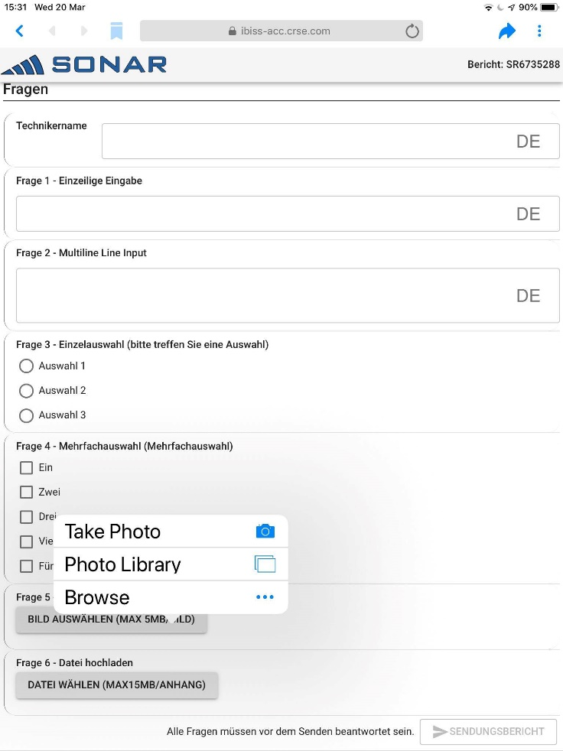

# Important notices



1. **The main goal for this tool is to get detailed repair feedback from our technicians. Please always provide as much detail as possible.**
2. **In case of pictures or other attachments, please make sure these are detailed and clearly show the defect or requested item.**
3. **All questions need to be answered** before a report can be submitted
4. In case you cannot provide an answer to the question, enter “N/A”.
5. Once a report is submitted, it can no longer be corrected.
6. Only upon repair completion all information is available in the system to make a judgment whether a report is potential or required.
7. **Only required reports** need to be entered and **submitted** to Sony.

# Who to contact in case of issues?

* In case you cannot enter any data in the SONAR reports, check with the local IT helpdesk.   
  If they are unable to resolve the issue, escalate to your local Regional Authorised Service Partner who in turn can escalate to SONY.